(Assembly) Manual for In-Incubator Microscope v1

Step by step guide for using the raspberry pi with the microscope

V0, 31.8.20180

B. Diederich

Table of contents

Introduction 3

Buying parts 3

3D printing components 3

Assembling the cubes 4

Soldering 4

Parts – Checklist 5

Step-by-step assembly guide 6

Install the firmware of all devices 9

Start the microscope 10

Start Experiment 12

Get the data from the device 15

Troubleshooting 16

# Introduction

This is a rough set of instructions to start building your own in-incubator microscope. It comes with the files in our repository <https://github.com/bionanoimaging/UC2-git> .

It guides you through the major steps which are

1. Buying parts
2. 3D printing components
3. Assembling sub-parts
4. Soldering parts
5. Flashing parts
6. Assembling Microscope
7. Quick-Start

It should serve as a growing manual rather then being a complete list with detailed trouble-shooting solutions. If you find any error or unclear sections; Feel free to contribute or report any erros. Thanks!

# Buying parts

A detailed list with all parts necessary for the microscope can be found under /Documents/. It’s not mandatory to get exactly the components you’ll find in the list-. The suppliers and prices may vary. If you have the abilities to order parts overseas everything gets much cheaper! Major components are the Raspi+Camera, Arduinos and Light sources.

The magnetic – snap-fit system which allows a very convenient connection between parts can be replaced by a soldered/wired connection which reduces the price and availability enormously.

# 3D printing components

In the folder CAD/In_Incubator_Microscope/STL you’ll find a list of exported CAD files. Those are ready to print:

|  |  |  |
| --- | --- | --- |
| Filename | Function | # |
| IN-INCUBATOR_MICROSCOPE_Assembly_base_4x2.stl | Base, holds Magnets, Cubes and electronic connectors | 1 |
| IN-INCUBATOR_MICROSCOPE_v0_05__RMS_Adapter_29.stl | Adapter for RMS-threaded Objective lenses | 1 |
| IN-INCUBATOR_MICROSCOPE_v0_10_Cube_LED_Array_10.stl | Cube-Adapter for LED-Matrix | 1 |
| IN-INCUBATOR_MICROSCOPE_v0_10_Cube_v0_18.stl | Cube | 2 |
| IN-INCUBATOR_MICROSCOPE_v0_10_Lid_el_v0_19.stl | Lid for cube which holds electronics | 3 |
| IN-INCUBATOR_MICROSCOPE_v0_11_BS_1inch_Mirror_Thorlabs_20.stl | Cube-Adapter for 1inch mirrors | 1 |
| IN-INCUBATOR_MICROSCOPE_v0_11_Mirror_Adapter_for_RaspiCam_16.stl | Cube-Adapter for Raspberry Pi Camera | 1 |

We printed the parts using an Ultimaker 2+ with ABS material. We won’t give a detailed set of instructions on how-to-print components here, but you can find nice explanations in several printing-wikis like this one: <https://www.3dhubs.com/knowledge-base> .

Parameters of CURA-Software are as follows:

* Infill-Density: 50 % (especially the cubes should have >40% infill due to stability)
* Layer height: .1 mm works fine
* Printing support: only the Z-focus needs some support to work properly, everything else is designed the way that it works out-of-the-box
* BRIM, etc.: You’re better of if you don’t use any BRIM

# Assembling the cubes

Putting together a cube and the Base-plate follows the IKEA-principle. Grab the stuff and tools, get angry, then it works. Below you’ll find a basic cube without any inlets. What you need are 4 cylinder-head (ISO 912, M3, 18mm long) screws which hold the Lid (turkis) in place of the cube (Green). The orientation of the Lid advices the position of the magnetic-fit connector which comes into the hole (if necessary). For a detailed descritption please have a look in the guide on how a basic design for cubes have to look like.

If a firror should go into the cube, you have to slide it in before – please wit care; 3D printed material might break. Once done, you can get the ball-magnets (6mm) ready and put them onto the screws. Place the Cube with the screws heading the 4 holes in the base on it. Apply some force, so that the balls snap into the 3D printed holes.

Done! Repeat it for the other components. It’s always the same mechanism.

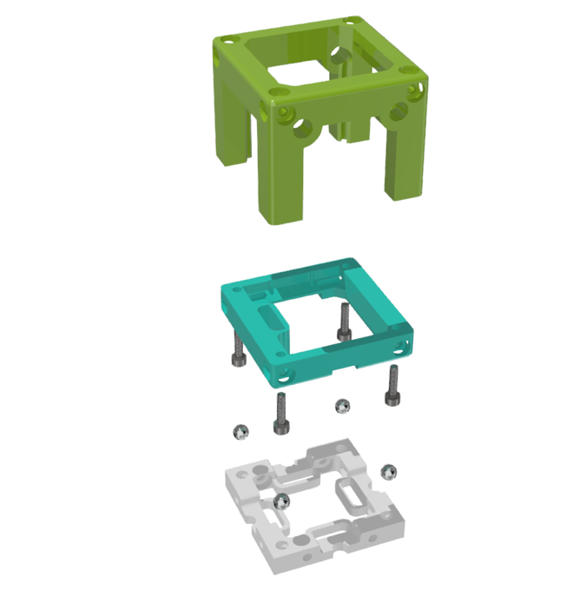

# Soldering

Soldering of the parts is very simple. You only need to make sure that all parts receive 5V and GND from a power-supply which has > 2A of “power”. The SCL and CLK coming from te Raspberry have to be attached to all Arduinos.

Specific functions like driving a stepper is explained in a dedicated folder “/Electronics”

Each electronic component works independent. If you’ve connected the IC2-able devices to the Raspi the first time (make sure that GND is the same everywhere) you can look for connected devices using the command

*IC2-detect -y -all*

Hints: It is possible to get the +5V/Gnd signal also from the raspberry pi. These pins are not fused, thus if there is a shortcut it can break!

# Parts – Checklist

If everything’s done, you should find the following parts. We have already renewed the Z-stage. Below you’ll find the “older version” of Richard Bowman’s design.

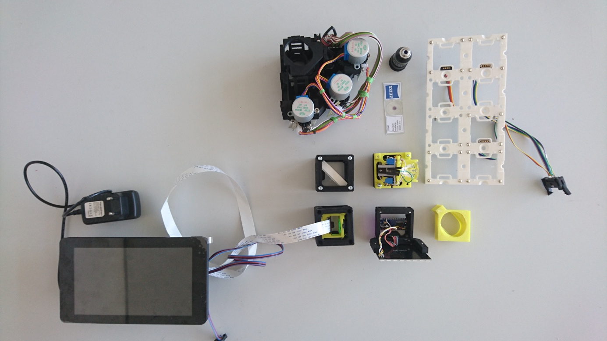

10

9

8

7

6

5

4

3

2

1

1. Raspberry pi with 7 inch screen
2. XYZ-stage
3. Mirror-Block
4. Cam-Block
5. Fluorescence Block
6. LED-Array Block
7. Backplate
8. Objective lens
9. Sample spacer
10. Sample

# Step-by-step assembly guide

1. Connect wires to magnetic connectors at the backplate

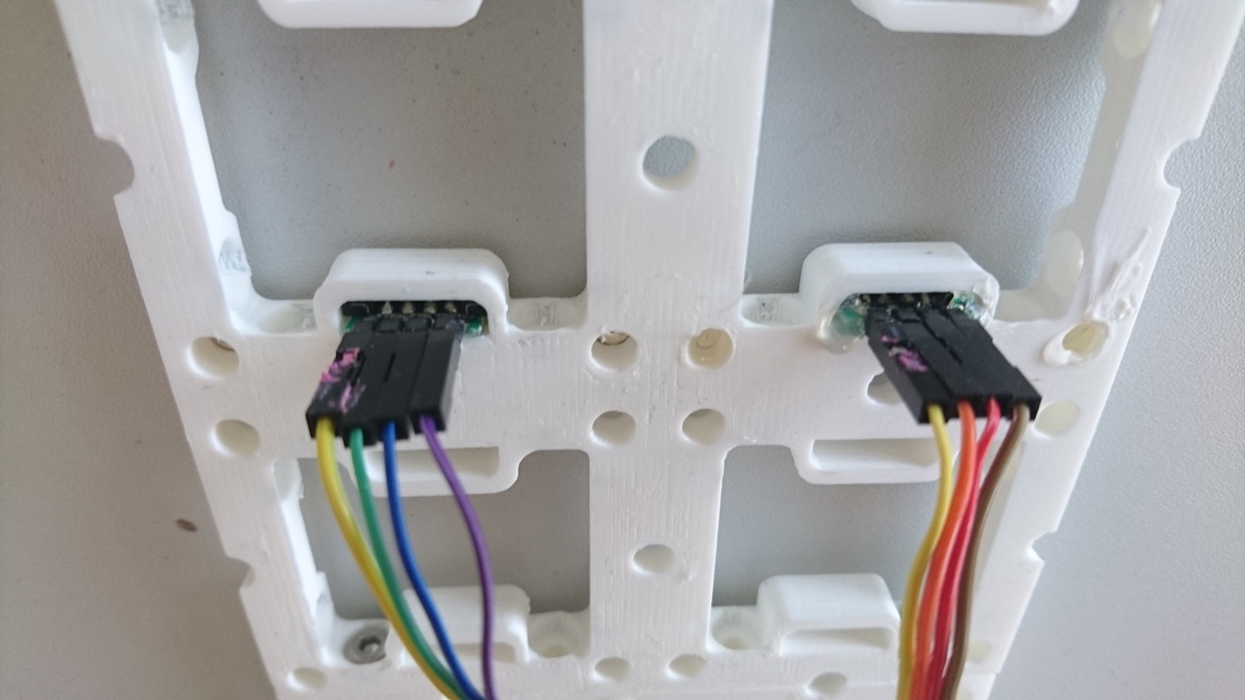

1. Put the microscope objective lens into the holder of the xyz-stage

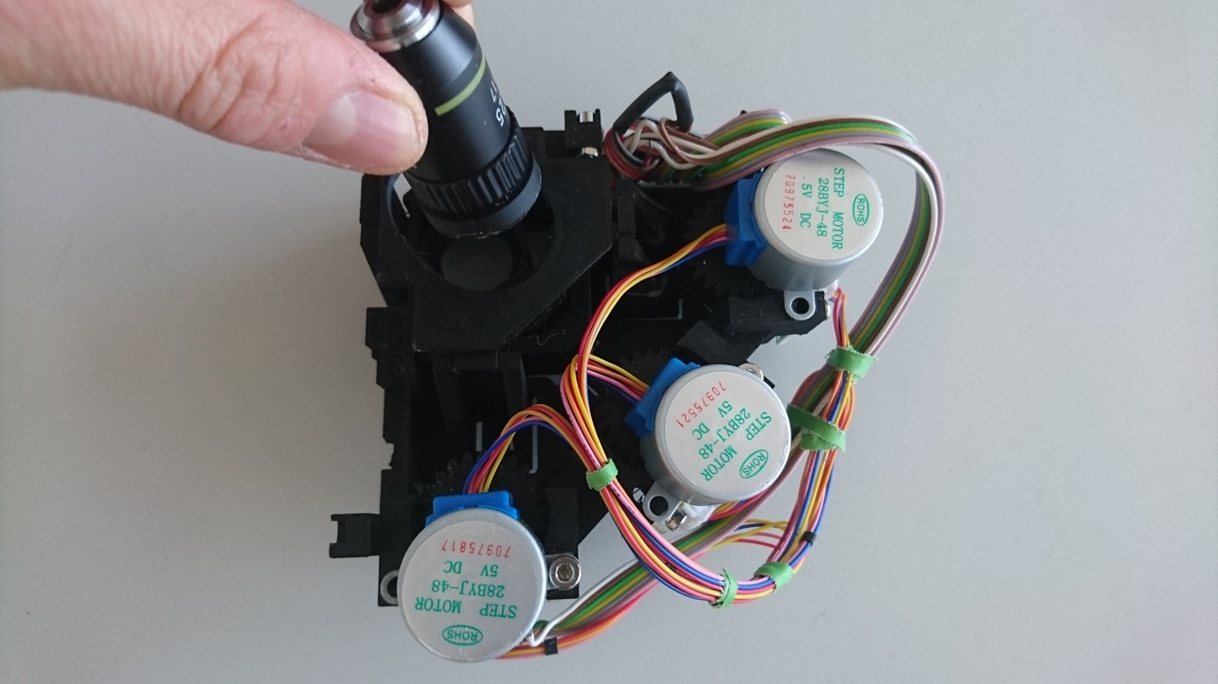

1. Allign the mirror-cube and the camera-cube

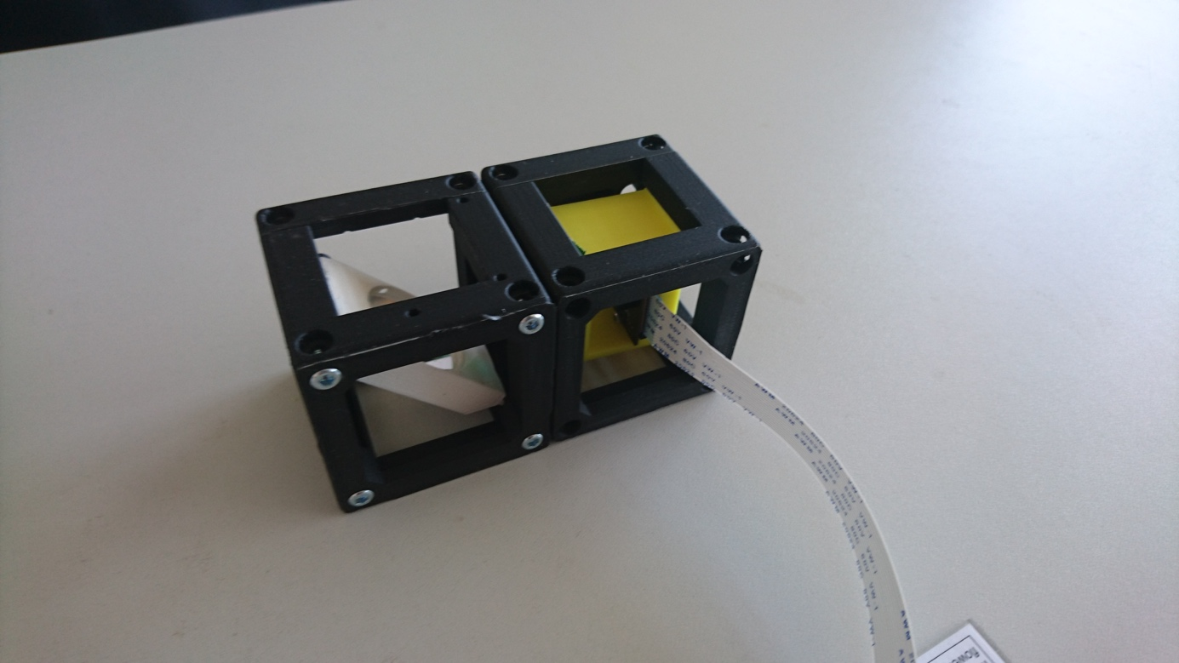

1. Attach the mirror- and camera block to the backplate

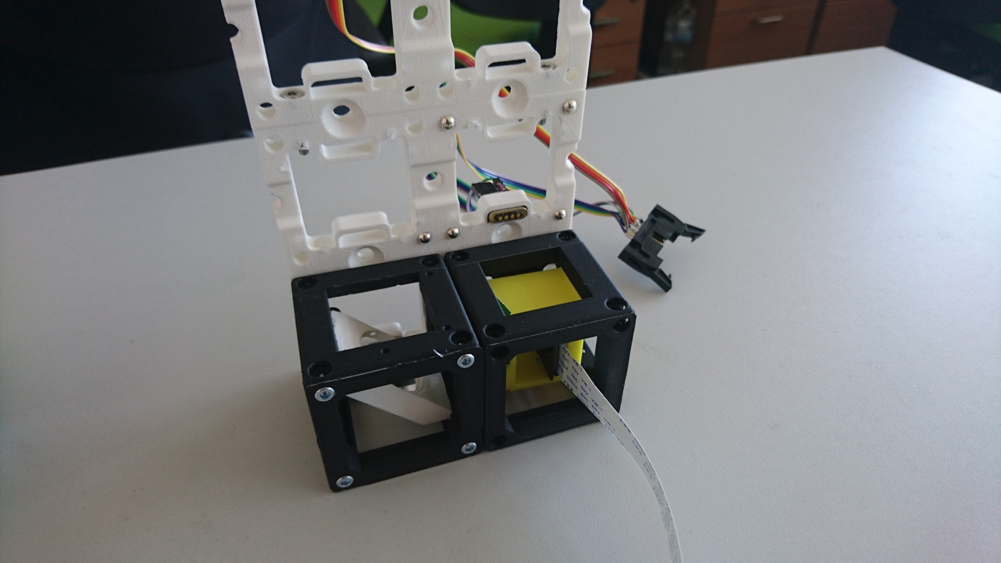

1. Attach the XYZ-stage to the backplate

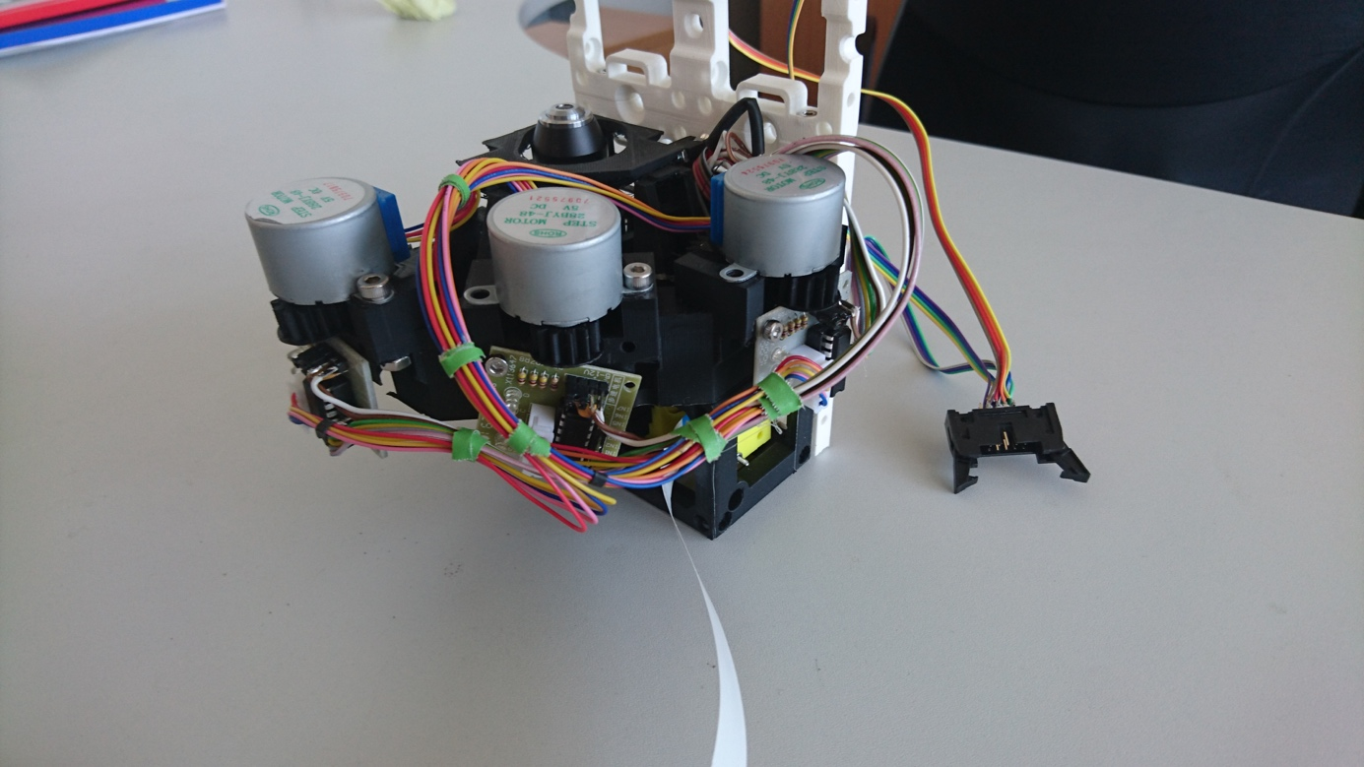

1. Put sample-spacer on the XYZ-stage and place sample on it

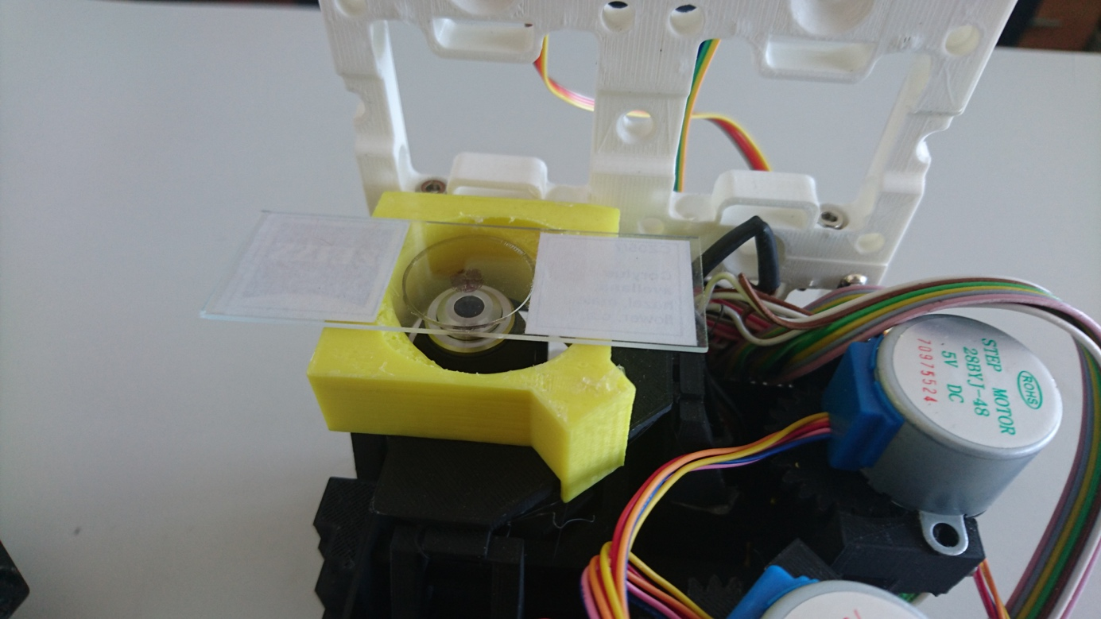

1. Attach LED-Array to the backplate

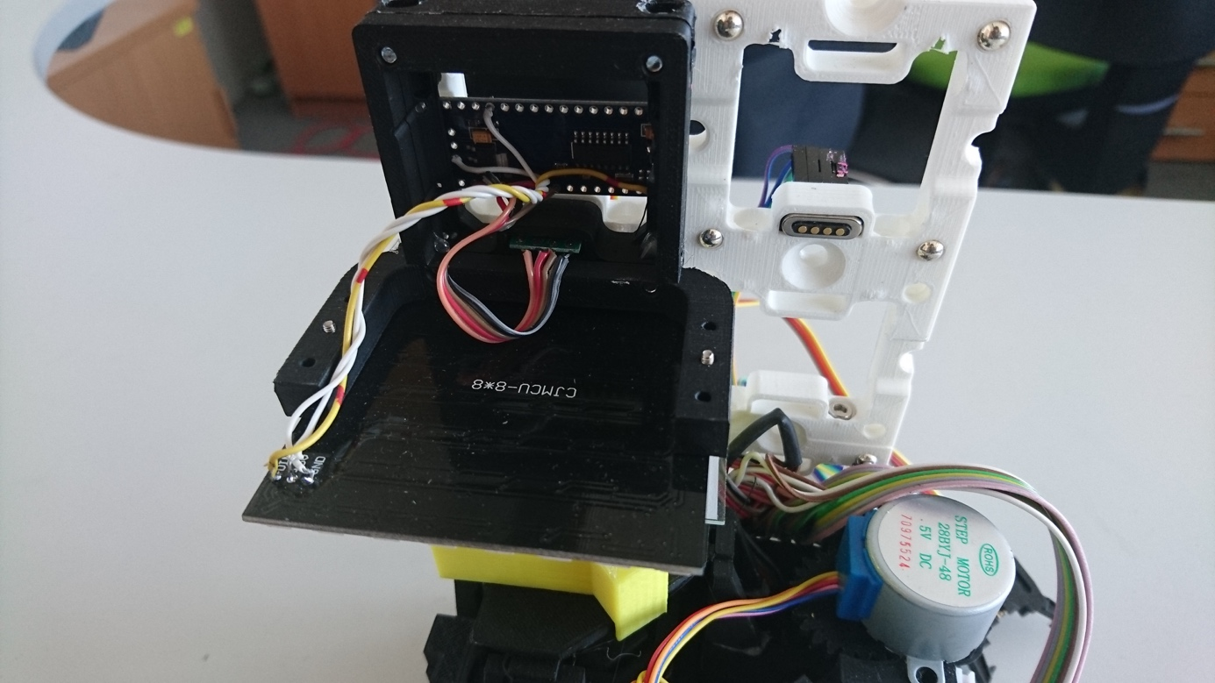

1. Connect backplate to the Raspberry-pi

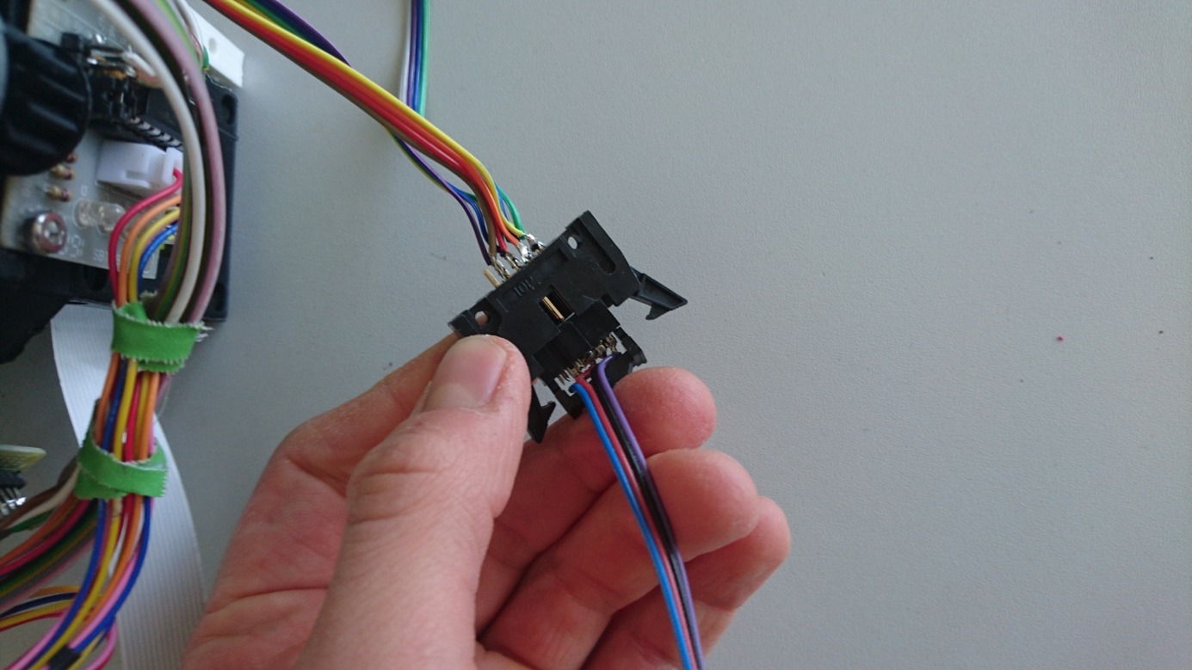

# Install the firmware of all devices

* Please a

# Start the microscope

1. Plug in the power-supply of the Raspberry-pi

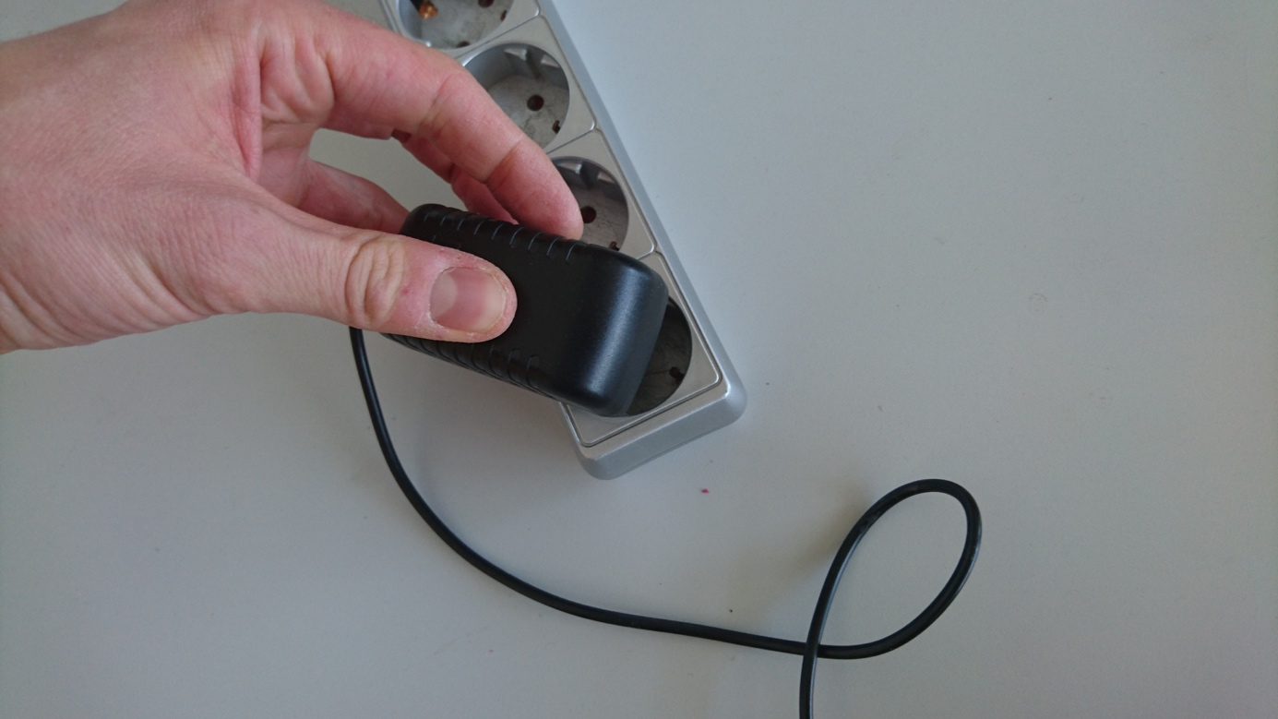

1. Let the Pi boot up

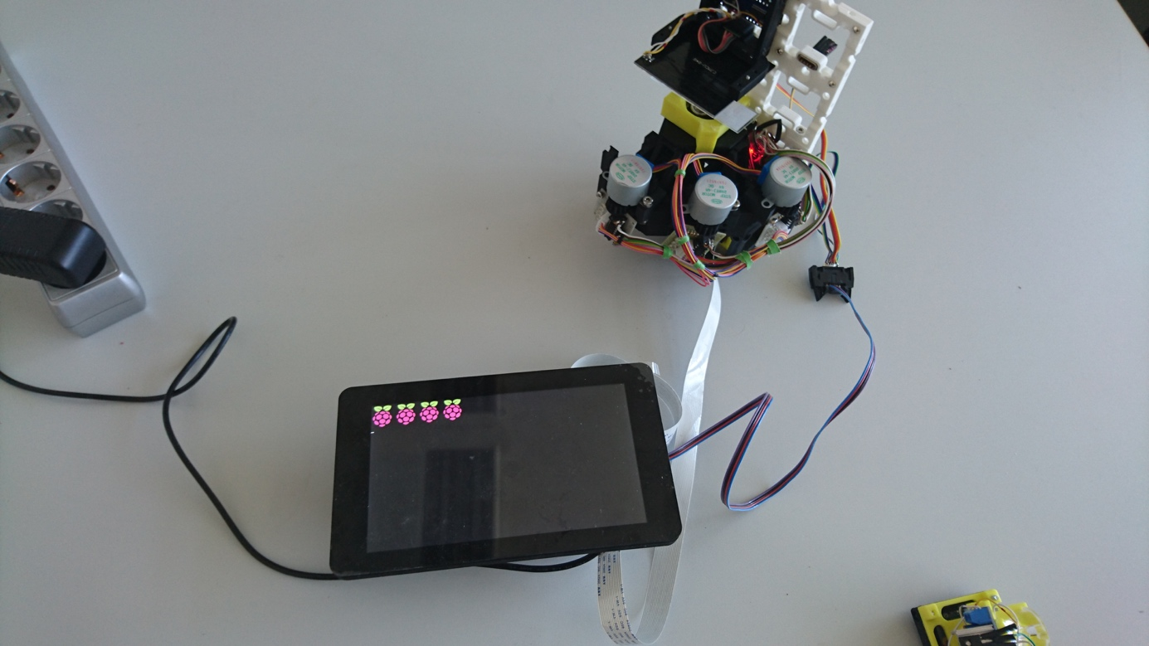

1. Wait about 30 seconds until the experiment scree appears

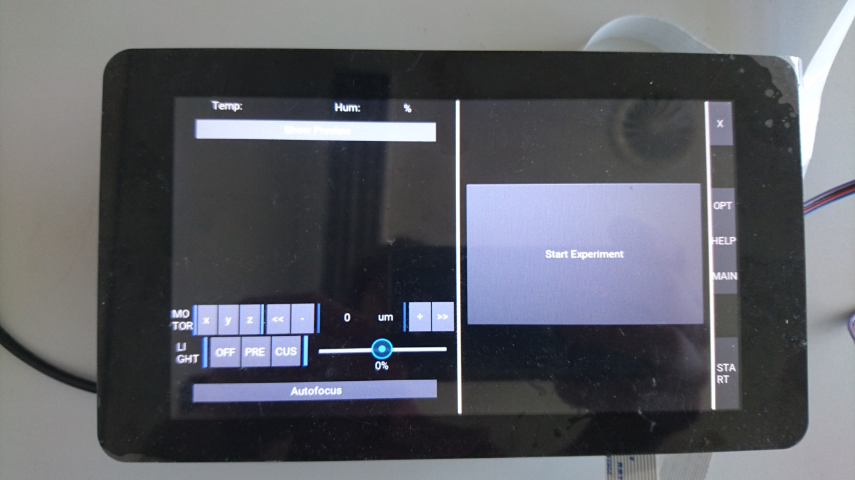

1. Aliging the smaple while switichg on the preview (Swith on Light, control focus and X/Y movement with the buttons)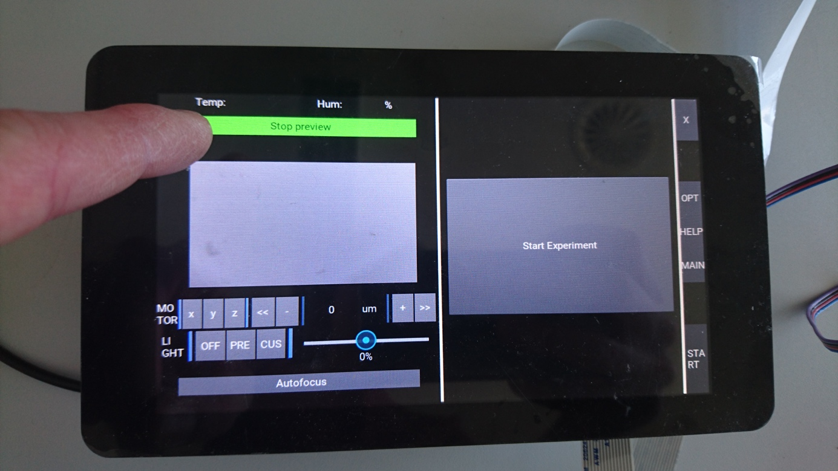

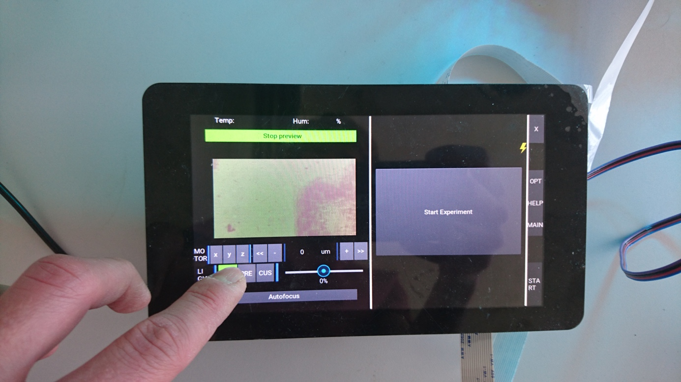

# Start Experiment

1. Select “Start Experiment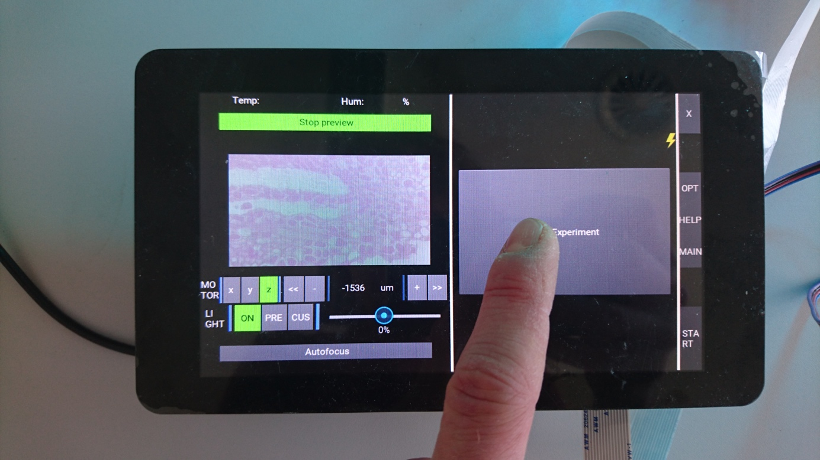
2. First choose Timing (Meas-iter, Total duration) then select acquisition method (i.e. Bright-field, qDPC, etc.)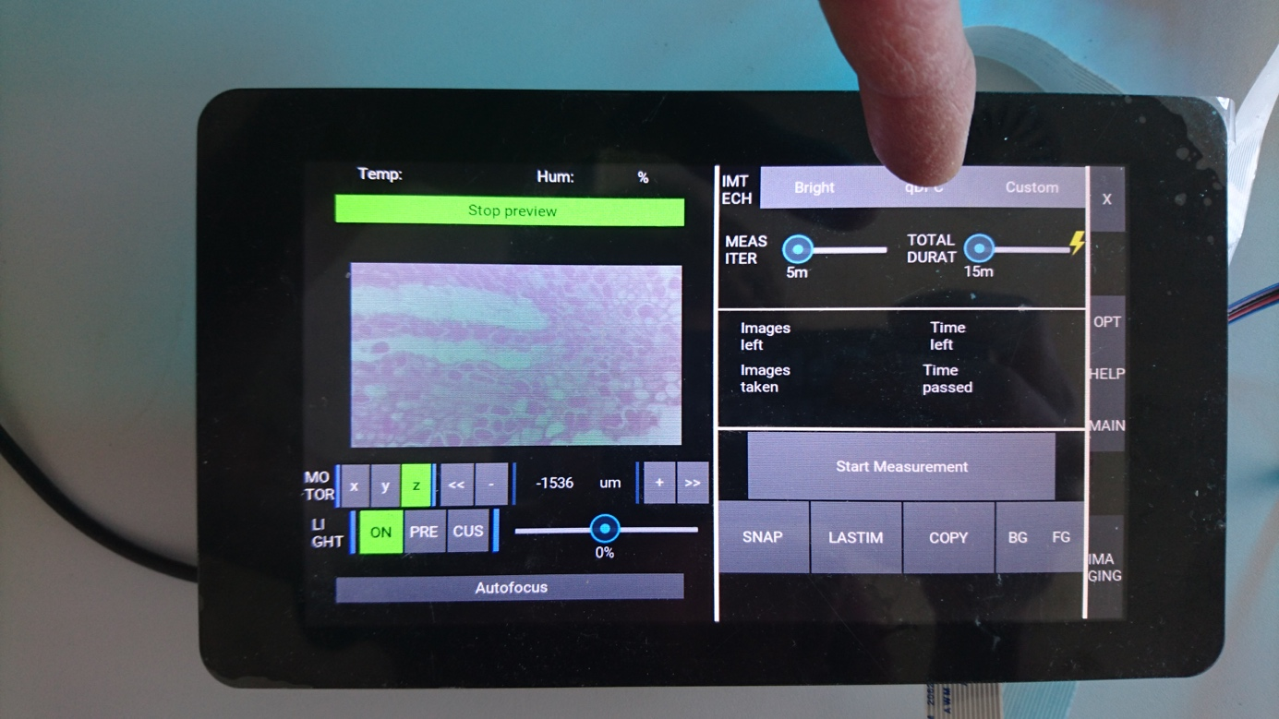
3. Choose Start Experiment
4. 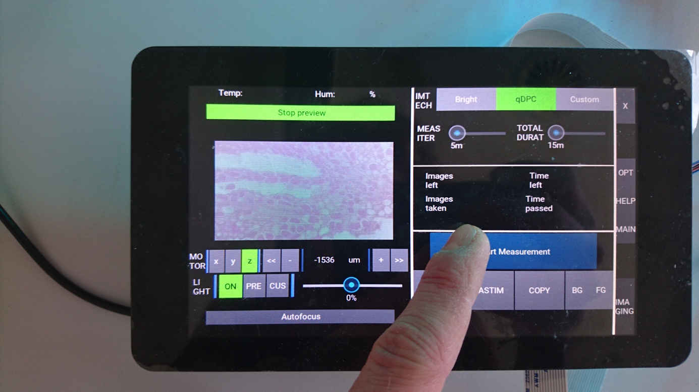
5. Experiment starts and can be stopped by pressing the stop-button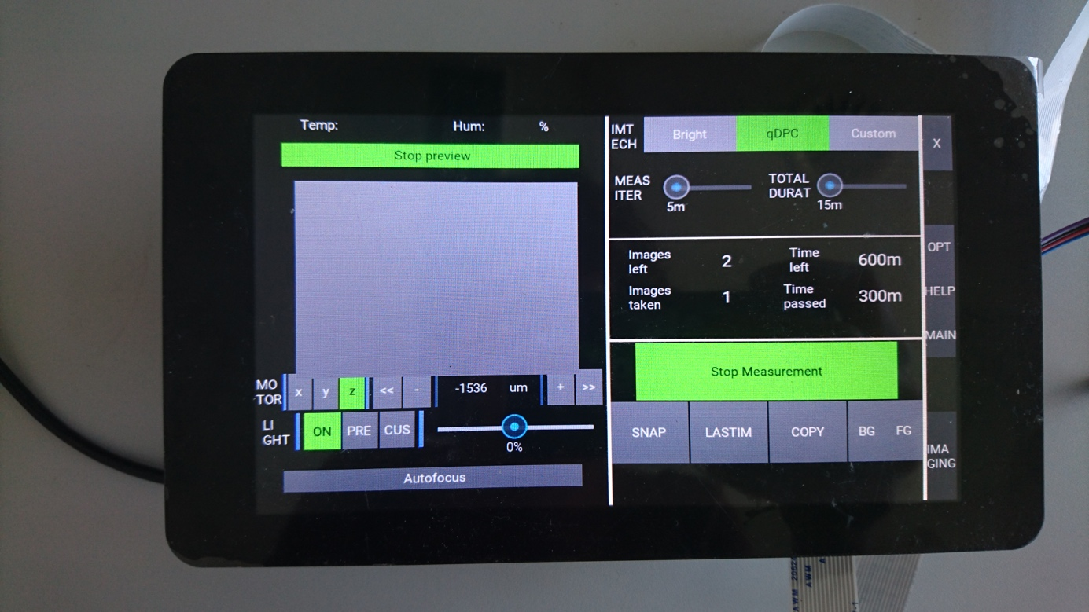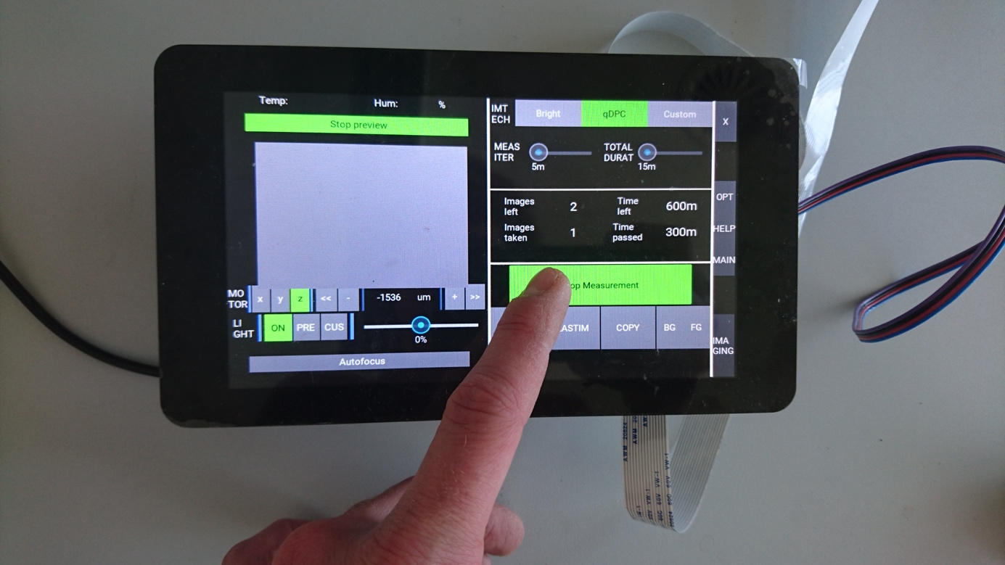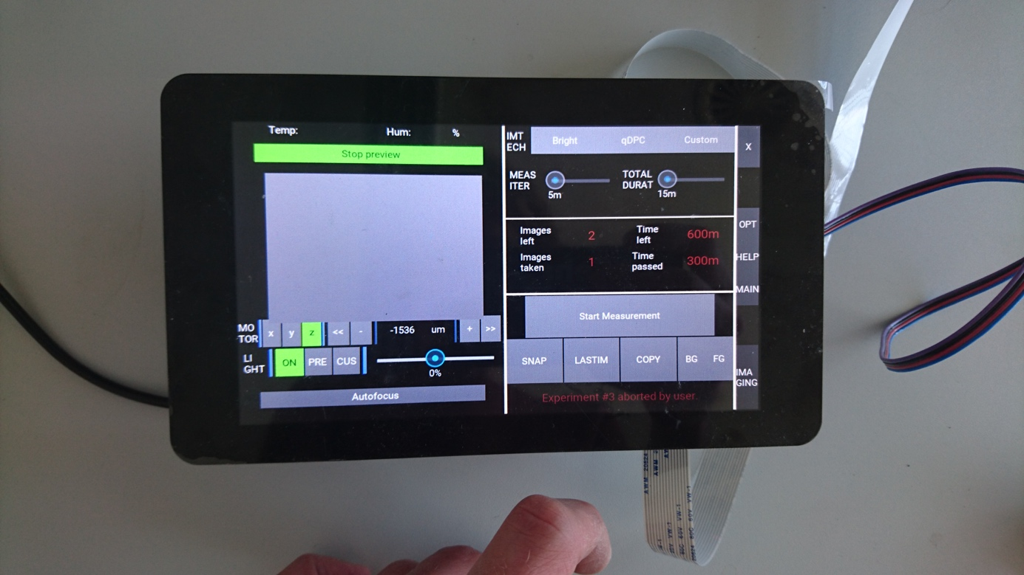

# Get the data from the device

# Troubleshooting

If everything fails unplug the device – if it still doesn’t work:

* Open the TERMINAL
* Type cd ~/Programming/PPS-app/code/
* Type python main.py

Copying the images

* Open the file explorer
* Plugin the device